# PROBLEMS IN PROCEDURAL PROGRAMMING



Session: 2021 – 2024

**Submitted by:**

Muhammad Ibrahim       2021-CS-169

**Supervised by:**

Miss Maida Shahid

Department of Computer Science

**University of Engineering and Technology**

**Lahore Pakistan**

# CONTENTS

Problems In Business Application: 3

Problems In Game Project:  3

# PROBLEMS IN BUSINESS APPLICATION

**Disjoint Data:**

* Example#1:

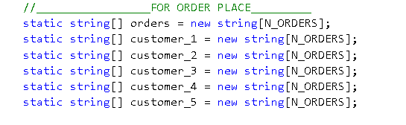

* Example#2:

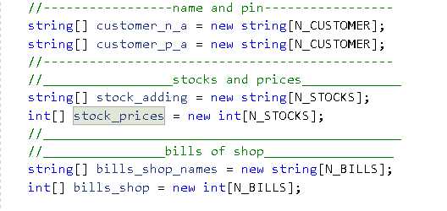

**Data Security:**

* Example#1:



* Example#2:



**Constraint on Data:**

* Example#1:



# PROBLEMS IN GAME PROJECT

**Data Security:**

* Example#1:



**Decoupling;**

